**Probability Distributions in R**

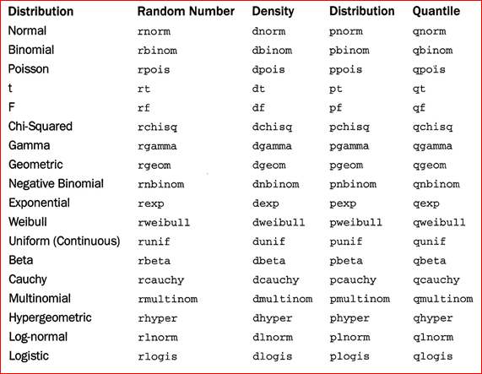

**References:**

**Davies, “The Book of R”, Chapter 16 pages 231-263.**

**Kabacoff, “R in Action” Section 5.2.3 pages 94-95.**

**Library Reserves: Lander “R for Everyone” pages 185-186.**